Things to note during installation :

1. Product languages Oracle DB and Client : add Vietnamese and English

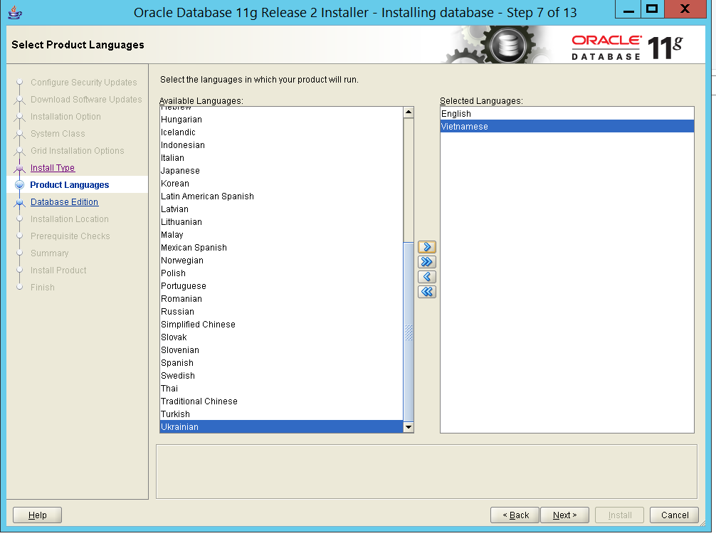

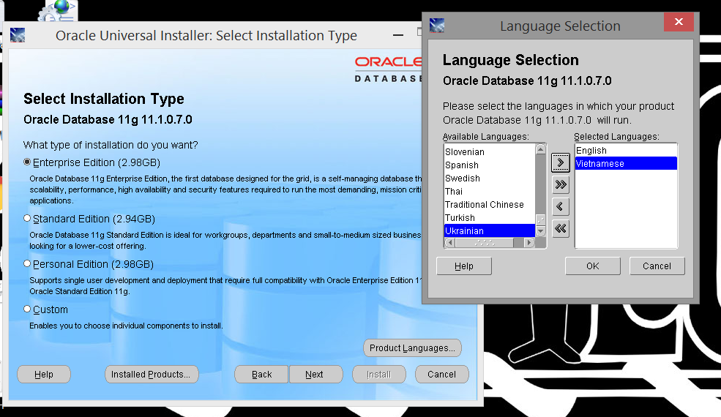

1. DB charactersets : Vietnamese DB character set

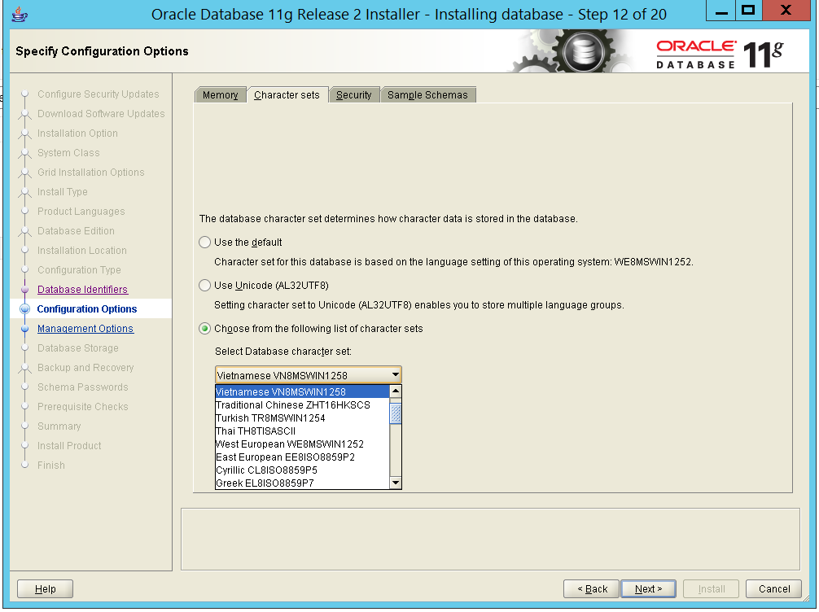

3. Oracle NLS_Parameters

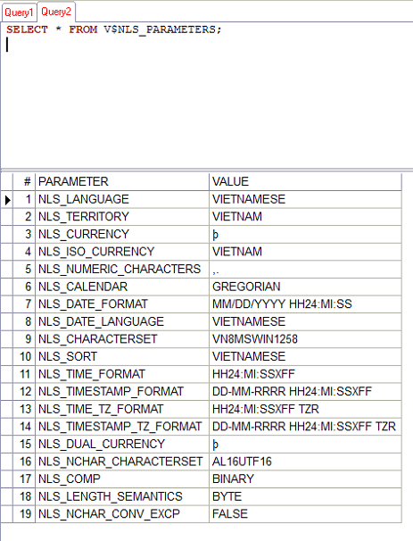

4. System Regedit values

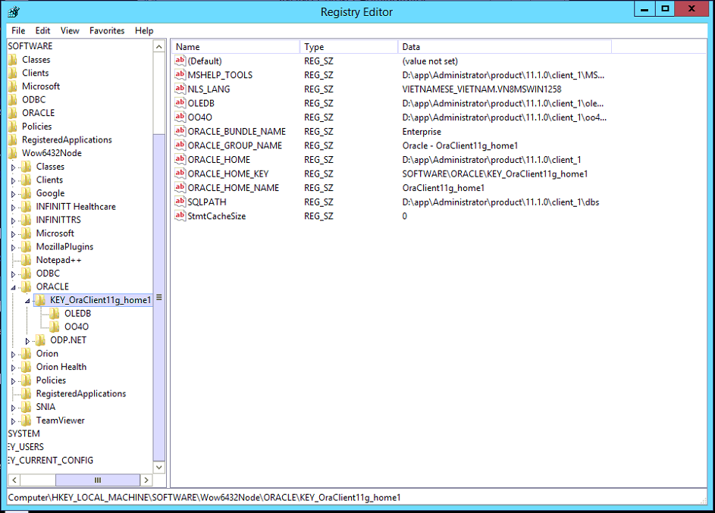

5. Use WDOServer2 and load Vietnamese profile

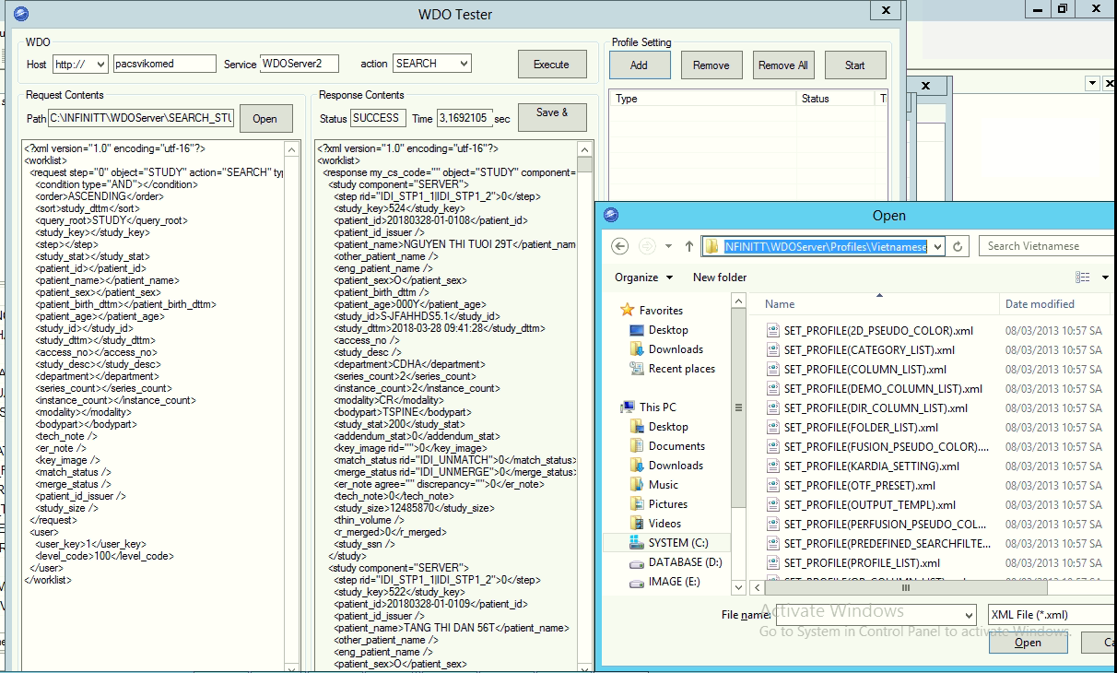

6. Run view spectra.sv_mwl_g3_viet.sql for workgate getting English MWL.

File is attached. In email.